# Question 01

## Code

clc

clear

close

A=.629;

rel=zeros(1,10);

app=zeros(1,10);

true_perct=zeros(1,10);

for i=1:length(rel)

% real value

rel(i)=A^(i);

% approx value

app(i)=floor(rel(i)*1000)/1000;

%True percent error

true_perct(i)=(rel(i)-app(i))*100/rel(i);

end

N=1:10;

plot(N,true_perct)

xlabel('N')

ylabel('True Relative Error')

title('Question 01')

hold on

% after rounding

% round

rel_r=round(rel,3);

app_r=round(app,3);

true_perct_r=(rel_r-app_r)./(rel_r)*100;

plot(N,true_perct_r)

grid on

legend('Rel_ error without rounding','Rel_ error with rouning')

## Output

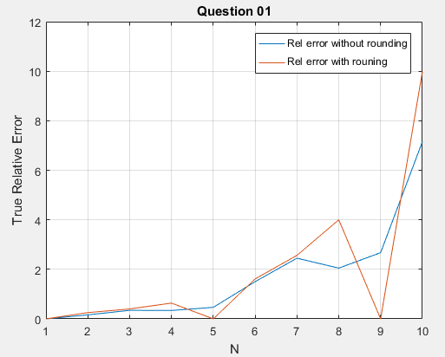

# Question 02

## Code

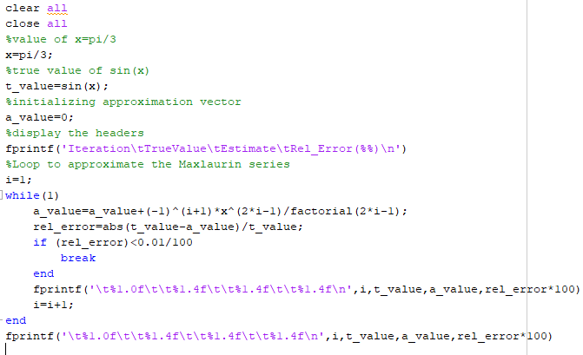

## Output

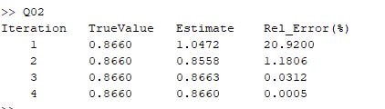

# Question 03

## Code

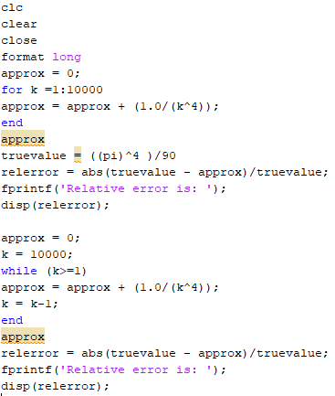

## Output

